CSCI217 - 2A

Anas Ahmed Hassan Sayed – 202000005

Rana Abdelaziz Tolba – 202000763

**Program functionalities:**

**Login**

**Admin view**

**Librarian view**

**Input verification:** using if statements and try and catch blocks we check and verify all inputs.

In case the user deleted all admins, enter name: ADMIN password: ADMIN to login as the default admin.

**Classes and files:**

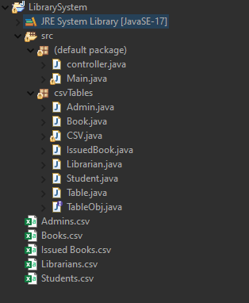

**Methodology:**

We have implemented our library system program based on MVC (Model, View, Controller) design pattern.

* The Model contains only the pure application data, it contains no logic describing how to present the data to a user.
* The View presents the model’s data to the user using a UI.
* The Controller exists between the view and the model. It listens to events triggered by the view and executes the appropriate reaction to these events.

**MVC**

**Model ->** CSV files - Admin.java – Book.java – Librarian.java – etc…

**View ->** Main.java

**Controller ->** controller.java – Table.java